WORKSHEET – 2.1

**Name:- Rahul Maurya UID:- 20BCS7260**

**Subject :- CN lab class/group:- CSE 716 B**

1. **Aim:**

Create a network connection using packet tracer, which shows the working of Switch and Hub. Explain in detail with proper steps.

1. **Task to be done/ Which logistics used:**

Cisco packet tracer

1. **Steps for experiment/practical/Code:**
2. Attach required devices (Hub/Switch/Router) in the packet tracer software.
3. Assign IP address to devices.
4. Select source and destination and drop packet from source to destination.
5. Go to Simulation mode and click capture/Play.
6. Simulation will start and packet will only be accepted by destination.
7. **Result/Output/Writing Summary:**

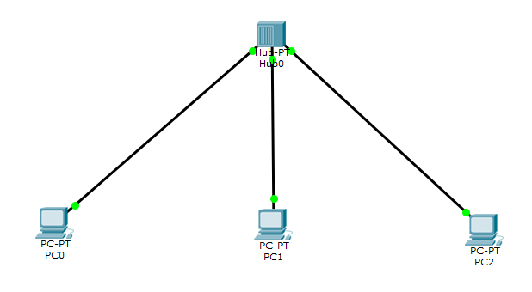

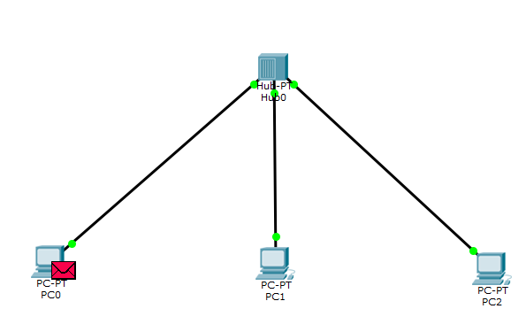

**Simulation:**

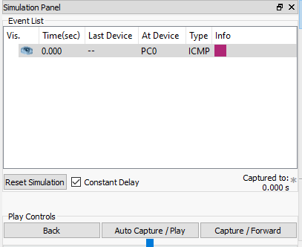

**Outcome:**

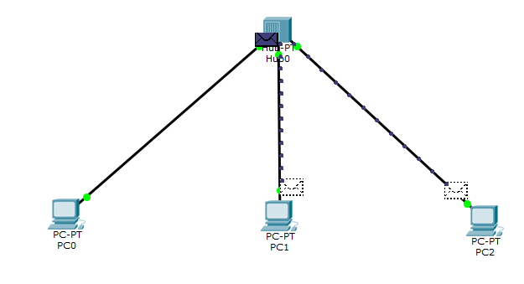

**Learning outcomes (What I have learnt):**

I understood the working of network devices.

# Evaluation Grid (To be created as per the SOP and Assessment guidelines by the faculty):

|  |  |  |  |
| --- | --- | --- | --- |
| Sr.  No. | Parameters | Marks Obtained | Maximum Marks |
| 1. |  |  |  |
| 2. |  |  |  |
| 3. |  |  |  |
|  |  |  |  |